**FinTrack**

Modern Accounting Software

GitHub Repository: <https://github.com/Bennidesign2003/FinTrack>

Version 1.0

January 2026

# Table of Contents

* 1. Overview
* 2. Features
* 2.1 Dashboard
* 2.2 Customer Management
* 2.3 Supplier Management
* 2.4 Invoicing
* 2.5 Payment Management
* 2.6 Reports & Analytics
* 2.7 Chart of Accounts
* 3. Screenshots
* 4. Installation
* 5. Technologies
* 6. Usage

# 1. Overview

FinTrack is a powerful, user-friendly accounting software specially developed for small and medium-sized enterprises. With a modern glassmorphism design and an intuitive user interface, FinTrack enables efficient management of finances, invoices, and business relationships.  
  
The application offers a complete solution for managing customer data, supplier information, invoice creation, payment tracking, and detailed financial reports. With real-time dashboards and interactive charts, you always maintain an overview of your business figures.

## Key Features:

* Echtzeit-Dashboard mit KPI-Overview
* Umfassende Kunden- und Supplier Management
* Professional invoice creation
* Detailliertes Payment Management
* Visual analytics and reports
* Strukturierter Chart of Accounts
* Modern glassmorphism design
* Responsive web application

# 2. Features

## 2.1 Dashboard

The dashboard provides a comprehensive overview of the most important business metrics:  
  
• Echtzeit-Overview über Gesamtumsatz, offene Rechnungen, Ausgaben und Gewinn  
• Interactive charts for revenue development and expense distribution  
• Drag & drop widgets for individual dashboard customization  
• Quick actions for frequent tasks  
• Current transaction list with invoices and expenses

## 2.2 Customer Management

Die Customer Management ermöglicht eine professionelle Verwaltung Ihrer Geschäftsbeziehungen:  
  
• Create and manage customer profiles  
• Store contact information, addresses, and tax numbers  
• Overviewliche Kundenliste mit Suchfunktion  
• Quick access to all customer data  
• Edit and delete customer entries

## 2.3 Supplier Management

Manage all suppliers centrally in one place:  
  
• Complete supplier database  
• Centrally manage business partner information  
• Contact details, tax numbers, and addresses  
• Quick access to supplier information  
• Overviewliche Tabellendarstellung

## 2.4 Invoicing

Professionelle Rechnungsverwaltung mit allen wichtigen Features:  
  
• Easy invoice creation  
• Automatic VAT calculation  
• Status tracking (Open, Paid, Overdue)  
• Invoice history and management  
• Overviewliche Darstellung aller Rechnungen  
• Total amount and statistics at a glance

## 2.5 Payment Management

Keep track of all expenses:  
  
• Track incoming and outgoing payments  
• Categorization by expense types (Material, Transport, Software, etc.)  
• Overviewliche Transaktionslisten  
• Date and description for each payment  
• Total expenses at a glance

## 2.6 Reports & Analytics

Comprehensive reporting functions for informed decisions:  
  
• Profit and loss statement (P&L)  
• Rechnungsstatus-Overview (Offen, Bezahlt, Überfällig)  
• Top categories by expenses  
• Visual data analysis with Chart.js  
• Latest invoices and payments  
• Coverage analysis (Revenue minus expenses)

## 2.7 Chart of Accounts

Strukturierter Chart of Accounts nach betriebswirtschaftlichen Grundsätzen:  
  
• Overviewlicher Kontenrahmen (Aktiva, Passiva, Erträge, Aufwendungen)  
• Categorization of income and expenses  
• Easy transaction allocation  
• Search function for quick access  
• Standard chart of accounts with descriptions

# 3. Screenshots

### Dashboard - Real-time overview with KPIs and charts

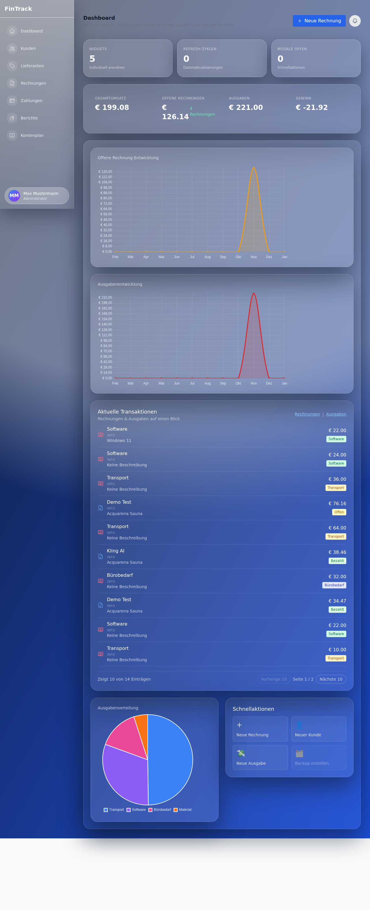

### Customer Management - Management of all customer information

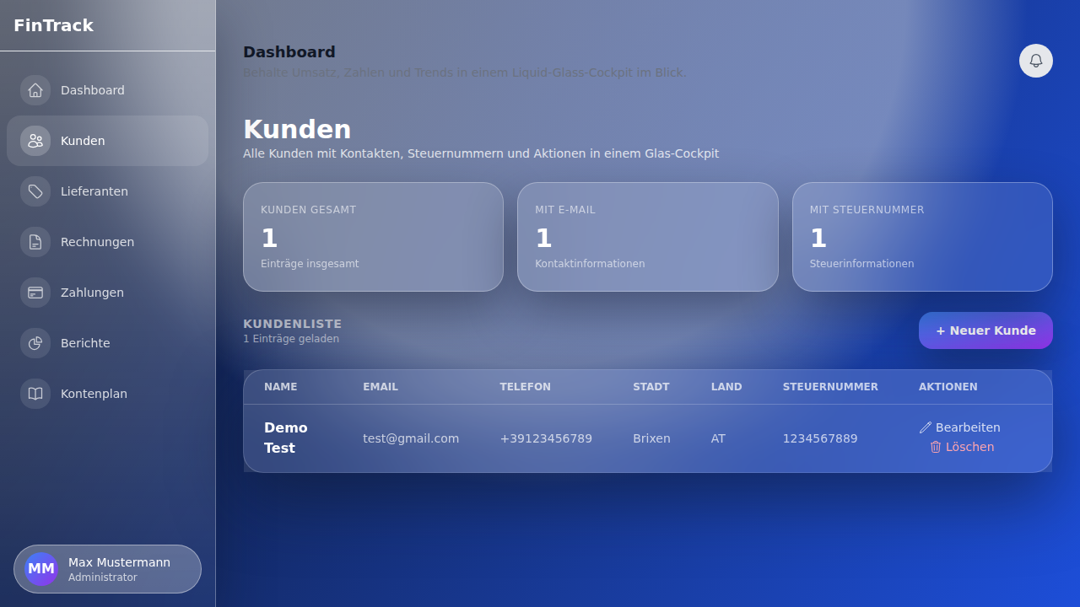

### Supplier Management - Central supplier database

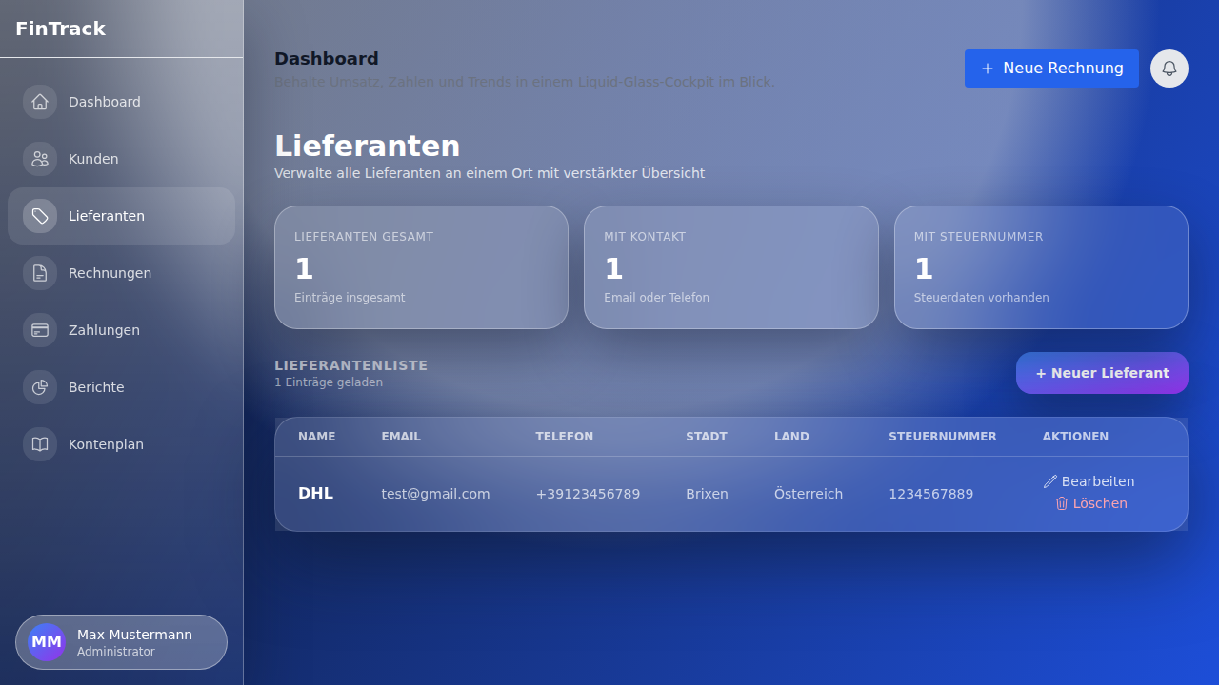

### Invoices - Status tracking and management

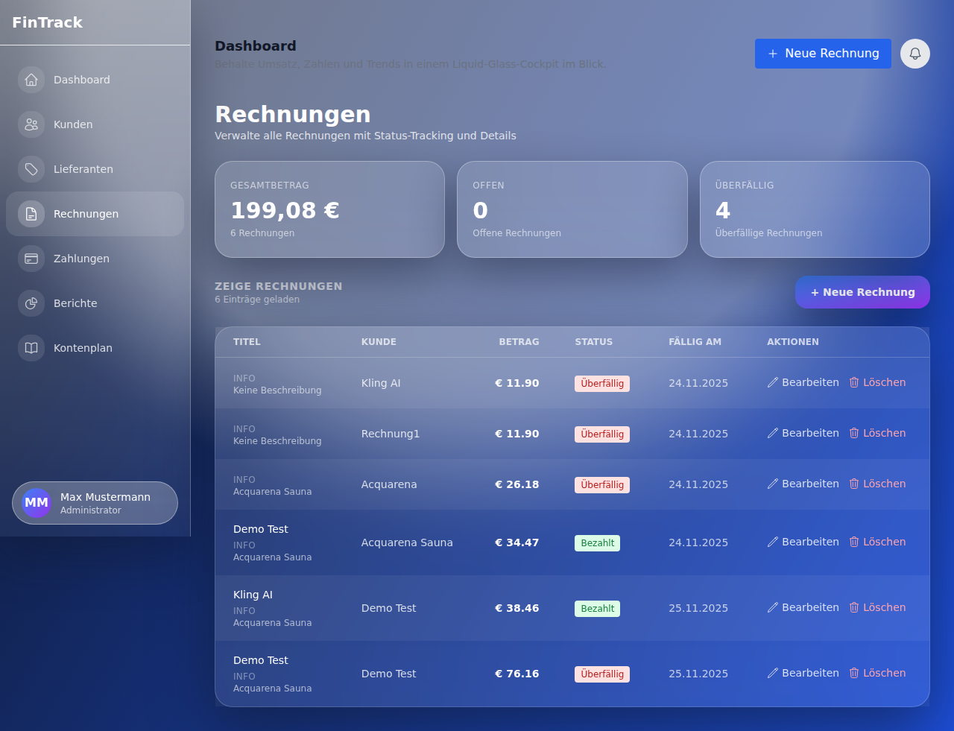

### Payments - Expense management by categories

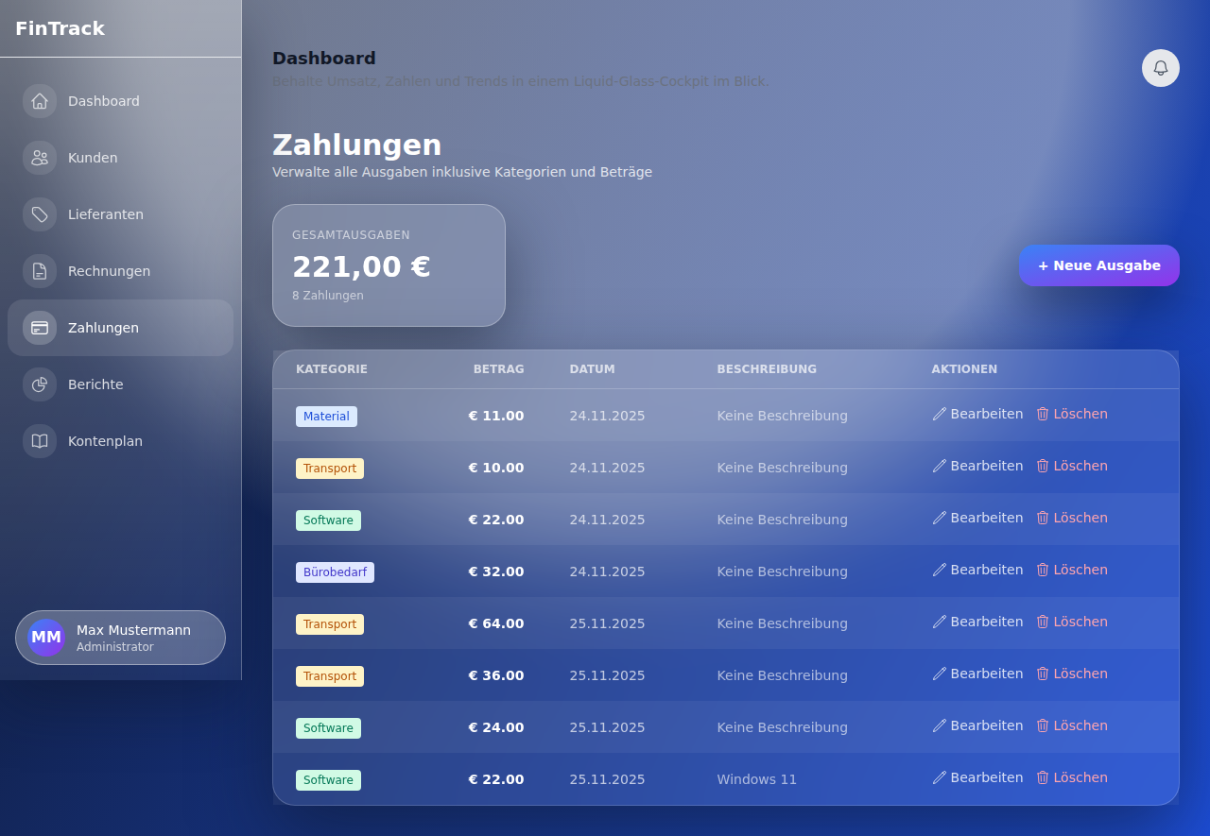

### Reports - Comprehensive analytics and statistics

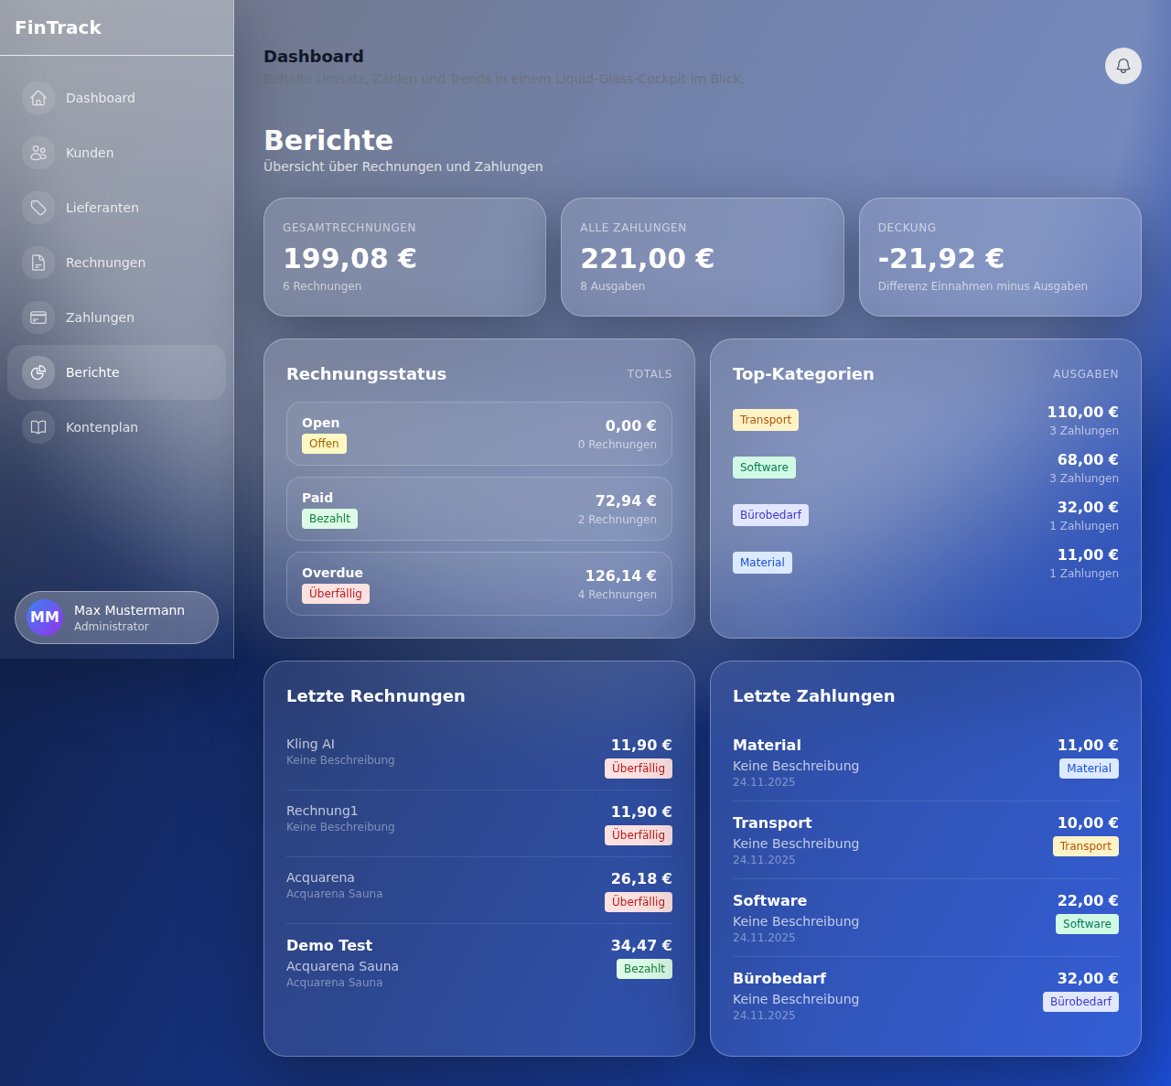

### Chart of Accounts - Structured overview

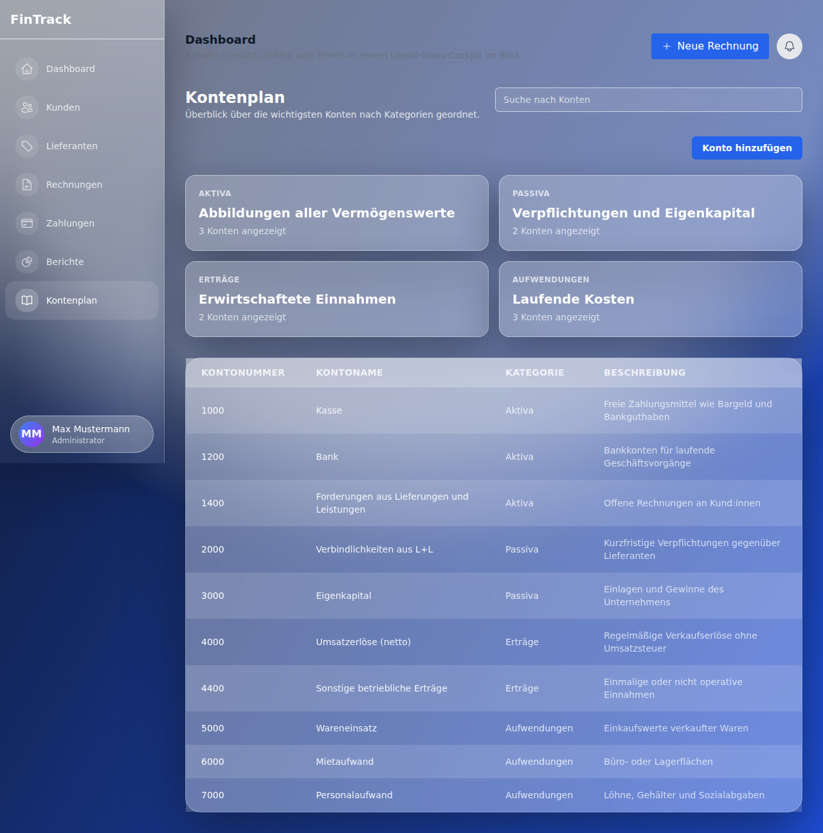

# 4. Installation

## Prerequisites

The following components are required for installing FinTrack:  
  
• Node.js (Version 18 or higher)  
• npm or yarn package manager  
• Git (optional, for cloning the repository)

## Quick Start

1. Clone the repository:

git clone https://github.com/Bennidesign2003/FinTrack.git

2. Navigate to the project directory:

cd FinTrack/Buchhaltung_App-main

3. Install dependencies:

npm install

4. Initialize the database:

npm run db:push

5. Start the development server:

npm run dev

6. Access the application:  
Open your browser and navigate to: **http://localhost:3000**

## Production Build

For production use:

npm run build  
npm start

# 5. Technologies

FinTrack basiert auf modernen Web-Technologies und Best Practices:

|  |  |
| --- | --- |
| Kategorie | Technologie |
| Frontend Framework | Next.js, React, TypeScript |
| Styling | Tailwind CSS, Glasmorphismus-Design |
| Datenbank | SQLite mit Drizzle ORM |
| Diagramme | Chart.js, react-chartjs-2 |
| Icons | Heroicons |
| Code-Qualität | ESLint, Prettier |

## Available Scripts

|  |  |
| --- | --- |
| Befehl | Beschreibung |
| npm run dev | Startet den Entwicklungsserver |
| npm run build | Erstellt den Production Build |
| npm start | Startet den Produktionsserver |
| npm run lint | Führt ESLint aus |
| npm run db:push | Synchronisiert das Datenbankschema |
| npm run db:studio | Öffnet Drizzle Studio |

# 6. Usage

After installation, you can use FinTrack as follows:

## Getting Started

1. Open the application in the browser (http://localhost:3000)
2. Navigate to the dashboard for an overall overview
3. Erstellen Sie neue Kunden über die Customer Management
4. Add suppliers
5. Create your first invoices
6. Erfassen Sie Ausgaben im Payment Management
7. Use the reports for detailed analysis

## Navigation

The main navigation is located on the left side and provides access to:  
  
• Dashboard - Zentrale Overview  
• Kunden - Customer Management  
• Lieferanten - Supplier Management  
• Invoices - Invoice creation and management  
• Payments - Expense management  
• Reports - Analytics and statistics  
• Chart of Accounts - Kontenübersicht

## Usage Tips

* Use the quick actions on the dashboard for frequent tasks
* Charts update automatically when data changes
* Use the search functions for quick access
* Categorize expenses correctly for meaningful reports
* Regularly check overdue invoices

# Further Information

For more information, updates, and support, please visit the GitHub repository:

<https://github.com/Bennidesign2003/FinTrack>

*Developed with ❤️ for efficient financial management*